 [Translated from Chinese (Simplified) to English - www.onlinedoctranslator.com](https://www.onlinedoctranslator.com/en/?utm_source=onlinedoctranslator&utm_medium=docx&utm_campaign=attribution)

**SCT1-86E**

**DC speed and torque regulating closed loop driver**

**User Manual V1.0.2**

Shenzhen Gerui IoT Technology Co., Ltd.

**Table of contents**

1. Product Introduction 1

1.1 Product Overview 1

1.2 Product Features 1

1.3 Application Areas 1

1.4 Naming conventions 2

2. Electrical, Mechanical and Environmental Indicators 3

2.1 Mechanical installation diagram 3

2.2 Enhanced heat dissipation 3

2.3 Electrical specifications 3

2.4 Operating environment and parameters 4

3. Driver interface and wiring introduction 4

3.1 Interface Diagram 4

3.2 Interface Description 4

3.2.1 Encoder interface 5

3.2.2 Motor control output interface 5

3.2.3 Power input interface 5

3.2.4 Burning and debugging interface 5

3.3 Wiring requirements 6

4. Functional Description 6

4.1 Panel Function Diagram 6

4.2 Digital tube display 7

4.3 Torque and speed adjustment 7

4.4 Start-Stop Control 7

4.4.1 Panel switch control start and stop 7

4.5 Special features 8

4.5.1 Maximum output torque value adjustment 8

4.5.2 Maximum output speed adjustment 8

4.5.3 Other functional adjustments 8

5. Power supply selection 9

6. Indicator lights and alarm indicators 10

VII. Warranty and After-sales Service 11

7.1 Warranty 11

7.1.1 Free warranty 11

7.1.2 Warranty exclusion 11

7.2 Exchange 11

7.2.1 Replacement of defective product 11

7.2.2 Exchange for non-product failure 12

7.3 Returns 12

7.4 After-sales service 12

8. Version Revision History 13

# Product Introduction

## 1.1 Product Overview

The SCT1-86E driver is a DC speed and torque adjustable closed-loop stepper driver newly launched by Gerui IoT Technology Co., Ltd. It has a 4-digit digital tube.The user can adjust the speed value and torque level value through the knob.Display the set speed value, torque level value; drive power supply voltage rangeDC24V~70V, mainly matches the closed-loop motor of 86 base, but can also drive the closed-loop motor of 42~60 base.

## 1.2 Product Features

●Small design, easy to install

●New generation 32-bit DSP technology, good stability, strong compatibility and high cost performance

●Can be adapted to closed-loop motors with 42~86 bases,Mainly matches the closed-loop motor of 86 base

●With 4-digit digital tube to display the speed value and torque level value

●The speed value and torque level value can be adjusted by the knob

●Control forward, reverse and stop through 3-position 3-pin switch

●Low vibration and low noise

●With overvoltage, undervoltage and other alarm protection functions

Input voltage range:DC24V~70V

## 1.3 Application Areas

Suitable for various small and medium-sized automation equipment and instruments, such as: intelligent logistics, textile industry, gate industry, winding industry, etc.

## 1.4 Naming conventions

The driver model naming rules are as follows:

SCT1-86E-🞎-🞎🞎🞎🞎

① ② ③ ④ ⑤ ⑥

|  |  |
| --- | --- |
| **Serial number** | **meaning** |
| ① | Product series name; SCT: speed control type product; |
| ② | Product series number; 1: The series number is 1; |
| ③ | Matching motor base; 86: mainly matching motors with 86 base; |
| ④ | Open loop/closed loop drive; E: closed loop; |
| ⑤ | Special function code; |
| ⑥ | Design change code; |

# Electrical, Mechanical and Environmental Specifications

## 2.1 Mechanical installation diagram

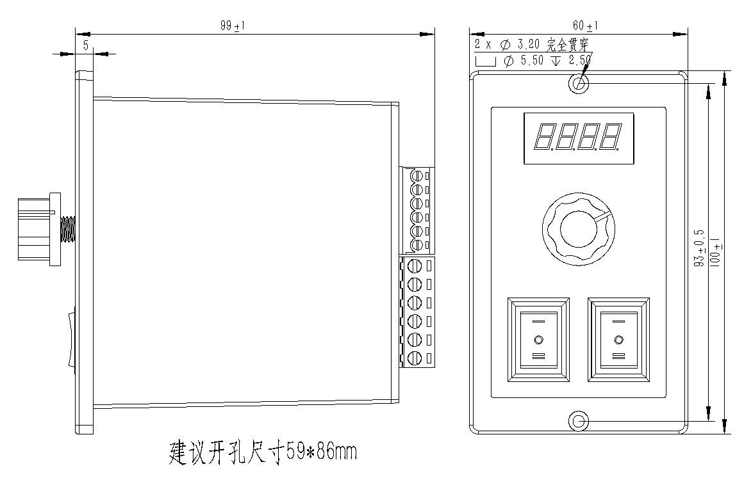

Figure 2.1 Installation dimensions (unit: mm)

**It is recommended to use side installation for better heat dissipation. When designing the installation dimensions, the size of the wiring terminals and the wiring should be considered.**

## 2.2 Enhanced heat dissipation

1. The reliable operating temperature of the driver is usually within 50℃, and the operating temperature of the motor is within 80℃;
2. When installing the driver, strong air convection can be formed on the side of the driver; if necessary, a fan can be installed inside the machine near the driver to form air convection, assist in drive heat dissipation, and ensure that the driver operates within a reliable operating temperature range.

## 2.3 Electrical specifications

|  |  |  |  |  |
| --- | --- | --- | --- | --- |
| **illustrate** | **SCT1-86E** | | | |
| **Minimum** | **Typical Value** | **Maximum** | **unit** |
| **Input DC power supply voltage** | twenty four | 48 | 70 | VDC |
| **Insulation resistance** | 50 |  |  | MΩ |

## 2.4 Operating environment and parameters

|  |  |  |
| --- | --- | --- |
| **Cooling method** | | **Natural cooling, fan cooling** |
| **Usage Environment** | **occasion** | Do not place it near other heating equipment. Avoid dust, oil mist, corrosive gas, high humidity and strong vibration. Flammable gas and conductive dust are prohibited. |
| **temperature** | 0——50℃ |
| **humidity** | 40-90%RH |
| **vibration** | 10~55Hz/0.15mm |
| **Storage temperature** | | -20℃~65℃ |

# Driver interface and wiring introduction

## 04289a4f784386a14e9294fb27871dd3.1 Interface Diagram

Figure 3.1 SCT1-86E interface diagram

## 3.2 Interface Description

The power supply and motor interface of SCT1-86E DC speed and torque regulating closed loop driver adopt 5.08-6P terminal block, the encoder interface adopts 3.81-6P terminal block, and the programming and debugging port adopts MINI USB interface. The specific definition of the interface is introduced in the following sections.

### 3.2.1 Encoder interface

|  |  |
| --- | --- |
| **name** | **Function** |
| PB+ | Encoder B phase input interface, please pay attention to the line sequence. |
| PB- |
| PA+ | Encoder A phase input interface, please pay attention to the line sequence. |
| PA- |
| VCC | Encoder 5V power supply positive terminal. |
| GND | Negative terminal of the encoder 5V power supply. |

### 3.2.2 Motor control output interface

|  |  |  |  |  |
| --- | --- | --- | --- | --- |
| **name** | | **color** | **illustrate** | **Function** |
| Motor | A+ | red | Motor interface | Two-phase stepper motor wiring port, pay attention to the line sequence |
| A- | blue |
| B+ | green |
| B- | black |

### 3.2.3 Power input interface

|  |  |  |  |
| --- | --- | --- | --- |
| **name** | | **illustrate** | **Function** |
| VDC | DC+ | Power interface | Support DC power input  DC24V~70V |
| GND |

### 3.2.4 Burning and debugging interface

The serial communication interface of the SCT1-86E driver uses a MINI USB interface, which can be connected to the PC through the dedicated debugging line provided by our company via the USB to TTL serial port conversion tool. Do not plug and unplug with power on! On the PC side, customers can set the required parameters, such as the maximum current value, the maximum speed value, etc. For details, please refer to the upper computer software interface.

|  |  |  |  |
| --- | --- | --- | --- |
| **Terminal No.** | **symbol** | **name** | **illustrate** |
| 1 | NC | - | Internal Use |
| 2 | NC | - | Internal Use |
| 3 | GND | Serial communication address | 0V |
| 4 | NC | - | Internal Use |
| 5 | NC | - | Internal Use |
| 6 | NC | - | Internal Use |
| 7 | RxD | Serial port receiving end |  |
| 8 | TXD | Serial port sender |  |

▶Note: The debugging line connecting SCT1-86E and PC is a dedicated line (provided according to user needs). Please check before use to avoid damage.

## 3.3 Wiring requirements

1. The motor line and encoder line must use shielded cables to prevent interference signals from entering the encoder signal end and affecting the operating effect, causing system instability and other faults.
2. If one power supply supplies multiple drives, they should be connected in parallel at the power supply. Chain connection from one drive to another is not allowed.
3. It is strictly forbidden to plug or unplug the high-voltage terminals of the driver while it is powered on. When the motor is stopped, there is still a large current flowing through the coil. Plugging or unplugging the terminals while it is powered on will cause a huge instantaneous induced electromotive force that will burn out the driver.
4. It is strictly forbidden to connect the wire end to the terminal after tinning it, otherwise the contact resistance may increase and the terminal may be damaged by overheating.
5. The wiring ends must not be exposed outside the terminals to prevent accidental short circuits and damage to the driver.

# Functional Description

## 4.1 Panel Function Diagram

The functional diagram of the SCT1-86E DC speed and torque regulating closed-loop driver panel is shown below.

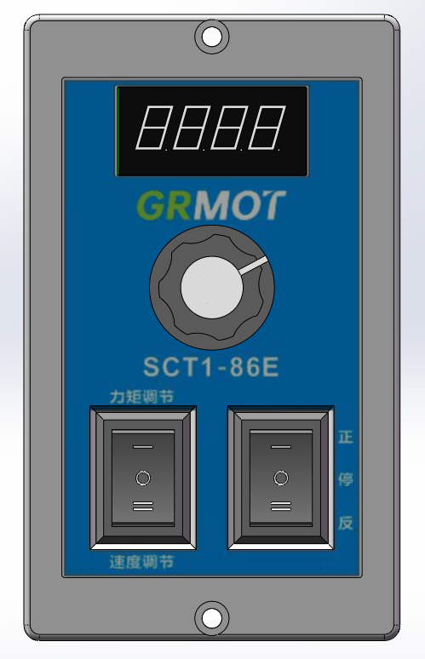

Figure 4.1 SCT1-86E panel function diagram

## 4.2 Digital tube display

SCT1-86E DC speed and torque regulating closed loop driver uses 4-digit digital tube to display speed value and torque level value.As shown in the following figure.

|  |  |
| --- | --- |
| **Digital tube display example** | **meaning** |
| 8fd2e1faf7ea5bb8d9192573244b308 | The digital tube displays 'C200', indicating that the current torque value is 200; at this time, the torque output value can be adjusted by the knob, and the default adjustment range is 0-200; |
| b049a5dbd965a246b61110614843e0c | The digital tube displays 'U200', indicating that the current speed output value is 200rev/min; at this time, the speed output can be adjusted by the knob, and the default adjustment range is 0-200rev/min; |
| 94386b35ff87b23adb2cd575c42c5dd | The digital tube displays 'U.200', indicating that the current speed is 200rev/min, and rotating the knob is invalid at this time, and will not affect the set torque value and speed value; |

## 4.3 Torque and speed adjustment

The setting range of torque value and speed value is 0-200. You can switch to the corresponding gear (torque mode or speed mode) through the 3-pin 3-speed switch, and then adjust it through the knob. The specific relationship is as follows:

|  |  |  |
| --- | --- | --- |
| **Torque, speedAdjustment switch position** | **Knob adjustment value** | **describe** |
| 'I' | Adjust the torque output value | Range: 0-200 |
| 'II' | Adjust the speed value output size | Range: 0-200, Unit: rev/min |
| 'O' | The knob adjustment function is invalid | - |

## 4.4 Start-Stop Control

### 4.4.1 Panel switch control start and stop

The 3-position switch on the front of the SCT1-86 drive panel can control the motor's forward, reverse and stop. The control logic is shown in the following table:

|  |  |  |
| --- | --- | --- |
| **Forward and reverse adjustment switch position** | **Motor motion status** | **describe** |
| 'I' | Forward | - |
| 'II' | Reversal | - |
| 'O' | stop | It will eventually be in a released state, allowing the user to rotate it without resistance |

## 4.5 Special features

### 4.5.1 Maximum output torque value adjustment

When the torque and speed adjustment switch is in the 'I' position, press and hold the knob for 3 seconds, and the digital tube will switch to the display shown in the figure below. At this time, the maximum output current of the driver can be adjusted by the knob. The default setting value is 4000, unit: mA, the adjustable range is 0-6000, and the resolution is 100; after setting the required maximum current value, press the knob switch, the set current (i.e. torque) maximum value will be automatically saved, and the current torque setting value Cxxx will be displayed.(xxx is the torque setting value).

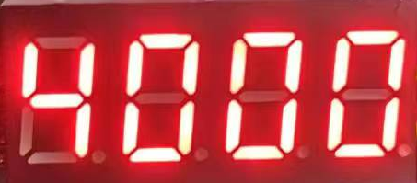

### 4.5.2 Maximum output speed adjustment

When the torque and speed adjustment switch is in the 'II' position, press and hold the knob for 3 seconds, and the digital tube will switch to the display shown in the figure below. At this time, the maximum speed of the driver can be adjusted by the knob. The default setting value is 200, unit: rev/min, the adjustable range is 0-3000, and the resolution is 1; after setting the required maximum speed value, press the knob switch, the set maximum speed value will be automatically saved and the current speed value Uxxx will be displayed.(xxx is the speed value).

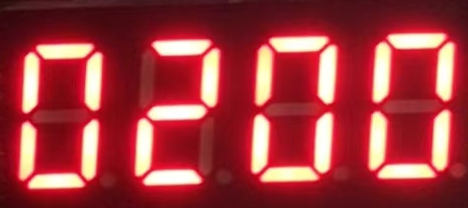

### 4.5.3 Other functional adjustments

When the torque and speed adjustment switch is in the 'O' position, press and hold the knob for 3 seconds, and the digital tube switches to the function display Pxxx (xxx is the function code) as shown in the figure below:

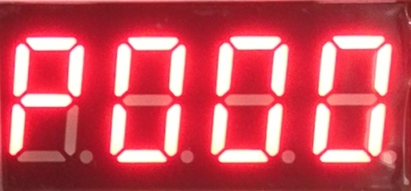

There are currently two selectable function codes: P000 and P001, which can be selected by the knob. After selecting the function code to be adjusted, press the knob switch to enter the corresponding parameter adjustment interface. The specific description of the function code is shown in the following table:

|  |  |  |
| --- | --- | --- |
| **Function code** | **Functional Description** | **Detailed Description** |
| P000 | Select the motor serial number | There are four optional values: 86, 57, 42, and 60, corresponding to four series of motors. The default setting value is 86. After selecting the corresponding motor series, press the knob switch to automatically save the selected motor series. Then the digital tube will normally display the current speed value U.xxx(xxx is the speed value); |
| P001 | Select the current ratio of the lock machine after shutdown | The setting range is 0~100, and the default value is 0. After setting the lock current ratio, press the knob switch to automatically save the set lock current ratio value, and then the digital tubeNormal display of current speed value U.xxx(xxx is the speed value); |

# Power supply selection

The power supply voltage can work normally within the specified range.The driver is best powered by a regulated DC switching power supply, and it should be noted that the output current range of the switching power supply must be set to the maximum. An unregulated DC power supply can also be used, but it should be noted that the peak value of the voltage ripple after rectification should not exceed the maximum voltage specified. It is recommended that users use a DC voltage lower than the maximum voltage to avoid grid fluctuations exceeding the driver voltage operating range.

If a voltage-regulated switching power supply is used, it should be noted that the output current range of the switching power supply must be set to the maximum.

**Notice:**

1. When wiring, pay attention to the positive and negative poles of the power supply and do not connect them in reverse;
2. When wiring, pay attention to the position of the power interface and do not connect it to the motor port. After connecting, it is best to confirm whether it is connected correctly;
3. It is best to use a regulated DC switching power supply;
4. When using an unregulated DC power supply, the power supply current output capacity should be greater than 60% of the driver set current;
5. When using a regulated DC switching power supply, the output current of the power supply should be greater than or equal to the operating current of the driver;
6. To reduce costs, two or three drivers can share one power supply, but the power supply must be large enough.

# Indicator lights and alarm indicators

The SCT1-86E DC speed and torque adjustable closed-loop driver displays the driver status through a digital tube. When the driver is powered on, the digital tube first displays 4 digits 0, and then displays the current speed setting U.xxx (xxx is the speed value). If the torque and speed switch is in the 'I' or 'II' position, it will switch to display Cxxx (xxx is the torque value) or Uxxx (xxx is the speed value).

When the drive fails, the digital tube will display Erxx (xx is the alarm code), as shown in Table 6.1 below.

Table 6.1 Digital tube status indication

|  |  |  |
| --- | --- | --- |
| **Digital tube display** | **Fault Description** | **Treatment measures** |
| 811b89e0f33262d2a49feffaac30fa3 | Overpressure alarm(Will not automatically return to normal state) | Check whether the power supply is normal;  Check whether the overspeed and overload phenomena are serious; |
| 0bc6c1817d86e809daf6e7c639e881e | Undervoltage alarm(Will not automatically return to normal state) | Check whether the power supply is normal; |

# Warranty and after-sales

## 7.1 Warranty

### **7.1.1 Free warranty**

Our company solemnly promises that for all products purchased from our company, if they are damaged due to the product itself during use, we will provide one year of free repair service. The round-trip shipping cost of the product shall be borne by both parties in half.

### **7.1.2 Warranty exclusion**

1. The driver is damaged due to the customer's own wiring error;
2. The drive is damaged due to exceeding the rated working voltage;
3. The DC power supply driver is connected to the AC power supply, causing the driver to be damaged;
4. The driver is damaged due to the customer's extremely harsh on-site environment, such as humidity, extreme cold, extreme heat, etc., without informing our company in advance;
5. The customer dismantles the drive housing without permission or the serial label number is torn off;
6. 15 days after the customer confirms receipt, the housing is obviously damaged or hit, resulting in damage to the drive;
7. Forceful natural disasters, such as fire, earthquake, tsunami, typhoon, etc.;

In the above cases, our company will charge a certain amount of repair cost after evaluating the interests of all parties. In other cases, repairs will be provided free of charge forever.

## 7.2 Exchange

### **7.2.1 Replacement of defective product**

For faults in new products, our company provides three months of free replacement service.

After our technical support staff confirms that the problem is with the product itself, they will send the product back to our company to avoid wasting time and postage on the round trip. Customers need to send the faulty product back by express or logistics first, and our company will send another new product back to the customer as soon as possible after receiving it.

**Notice:**All our products undergo rigorous testing and aging before leaving the warehouse, so it is extremely rare for new products to malfunction. Please be sure to read the instructions carefully or consult our technical support staff when operating, or our technical support staff will remotely assist customers in operating.

* **Please note the following points when exchanging goods:**

1. Please ensure that the packaging is complete when sending back to avoid damage during transportation;
2. Please ensure that the attached accessories are complete when exchanging;
3. Each driver should be packed in its original box to avoid secondary damage to the product during transportation;
4. If after the driver is sent back, it is confirmed that the failure is not due to product failure, but due to the customer's negligence in operation, which leads to mistakenly thinking that the driver is faulty, the company will not bear the shipping fee (the customer's negligence in operation includes: damage to the driver due to wrong wiring, poor wiring leading to mistakenly thinking that the driver is damaged, operation errors causing the driver to fail to work properly, etc.).

### **7.2.2 Exchange for non-product failure**

If the customer is not satisfied with the appearance or function of the product received and wants to replace it with a better driver, he or she can apply for a replacement service from our company within one week of receiving the product. After verification, our company will return the product. If the returned product is confirmed to be undamaged, with complete accessories and good packaging, the company will replace it with another product for the customer. For the replaced product, if there is a price difference, the customer will make up the difference.

**Note: The replaced product will no longer be eligible for the non-product fault replacement service. The round-trip shipping costs and other costs incurred by the non-product fault replacement service shall be borne by the customer!**

## 7.3 Returns

Our company provides a 7-day return service for products with quality problems. If you find quality problems with the product within 7 days of receiving the product (based on the actual date of receipt by the customer), please communicate with our salesperson or technical support personnel in time. After our technical support personnel confirms that it is a quality problem of the company's product itself, the customer can send the original complete product and its inner and outer packaging, accessories and shipping order back to our company by express or logistics.

If the customer still insists on returning the goods after our company has checked and confirmed that they are correct, the round-trip shipping costs and all other costs incurred shall be borne by the customer.

* **Please note the following points when returning goods:**

(1) Please contact the relevant department of our company before making a refund;

(2) The product must be in new condition and intact packaging. Please send it back to our company by express or logistics;

(3) We will not accept any complaints caused by customers, such as product appearance damage, incomplete accessories, etc.

## 7.4 After-sales service

If you need after-sales service support when using this product, please contact our company as soon as possible.

National free service hotline: 0755-23206995;

Website: http://www.grmot.com//

Technical specialist service hotline: 18576758897 (Mr. Xie), 17666115681 (Mr. Tuo);

Service hours: 8:30-17:30, Monday to Friday (except national holidays).

# Revision History

|  |  |  |  |
| --- | --- | --- | --- |
| **Version Number** | **illustrate** | **Modify deadline** | **Preparer/Reviewer** |
| V1.0.0 | Initial use version; | 2024.6.27 | TCJ, JQ/XH |
| V1.0.1 | 1. Optimized chapter 4.5; 2. Changed chapter 6: indicator lights and alarm indications; | 2024.7.29 | TCJ/XH |
| V1.0.2 | 1. The Chinese description of the drive model has been changed, and the torque percentage has been changed to the torque level value; 2. The driver power supply voltage related parts are changed to support only DC power supply; 3. In the table in Section 4.5.3, the detailed description of P001 adds the parameters of motor 60; 4. Modified the schematic diagrams in Sections 3.1 and 4.1; 5. Chapter 5 updated the power supply description; | 2024.10.30 | TCJ, JQ/XH |